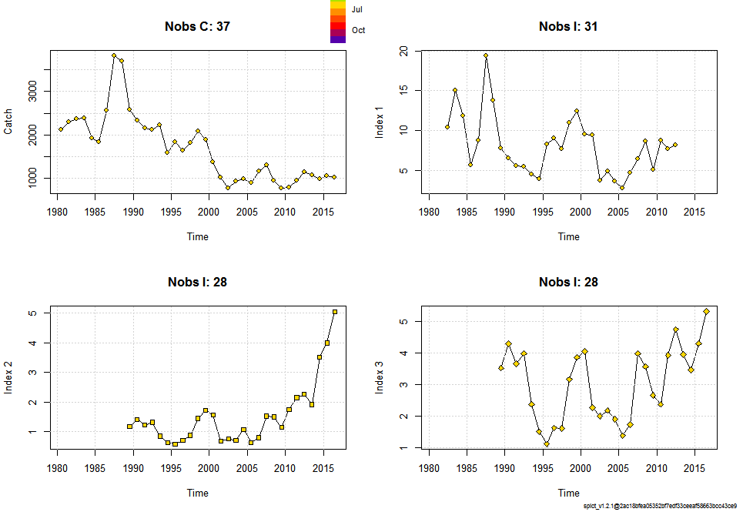

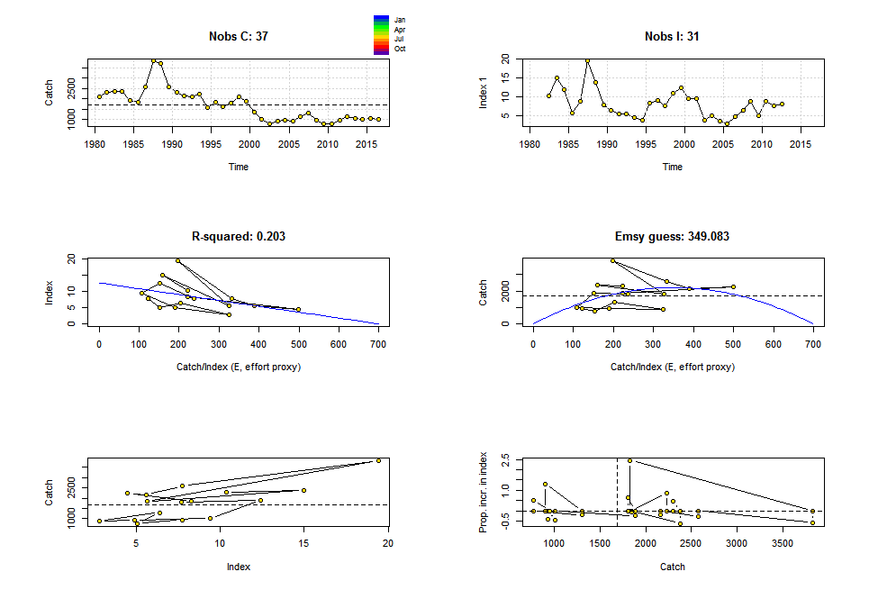

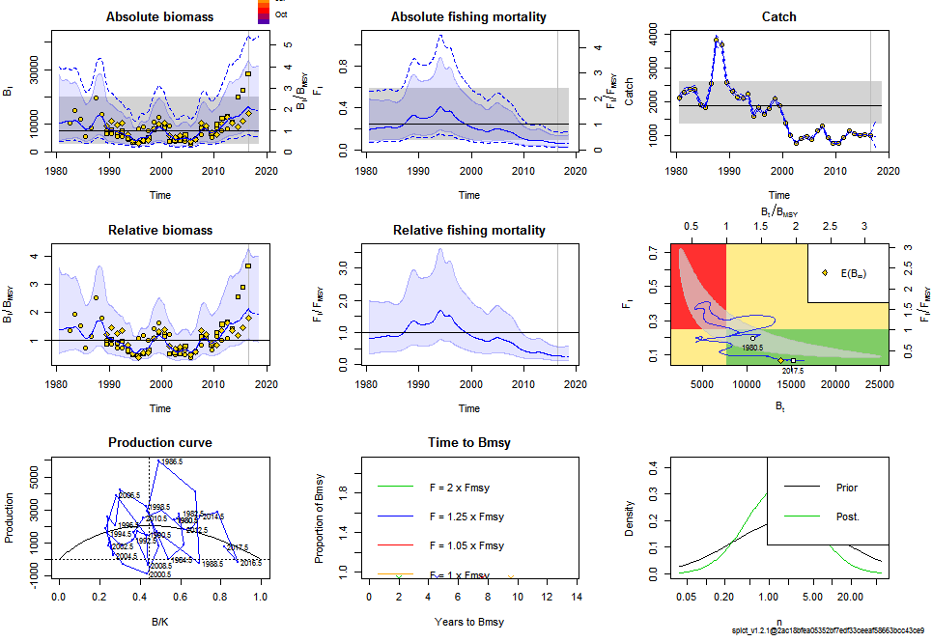

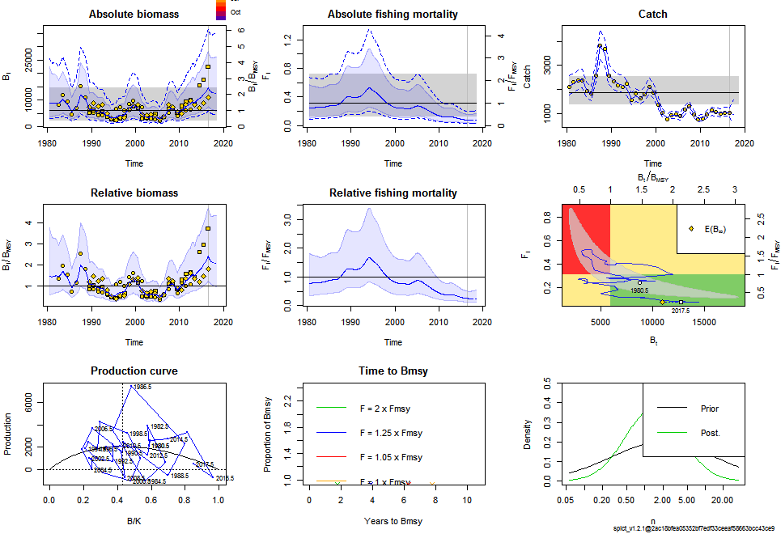

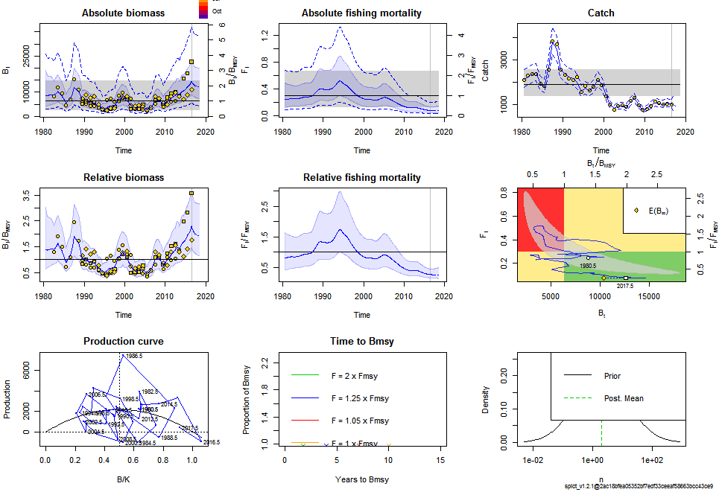

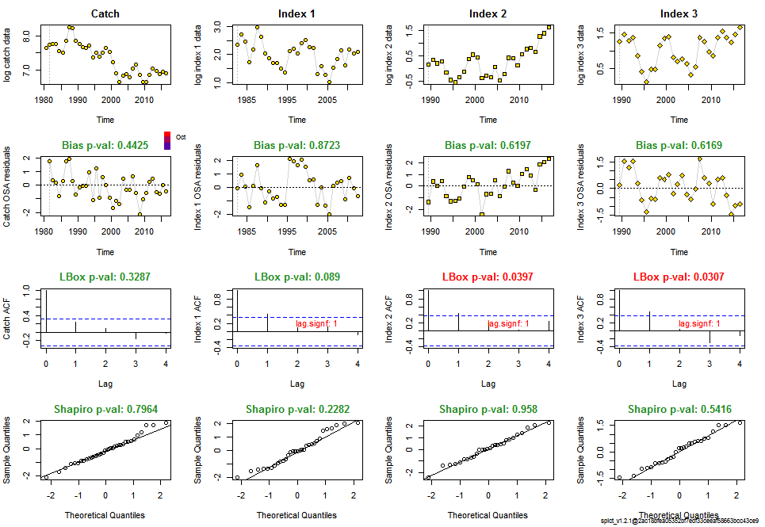

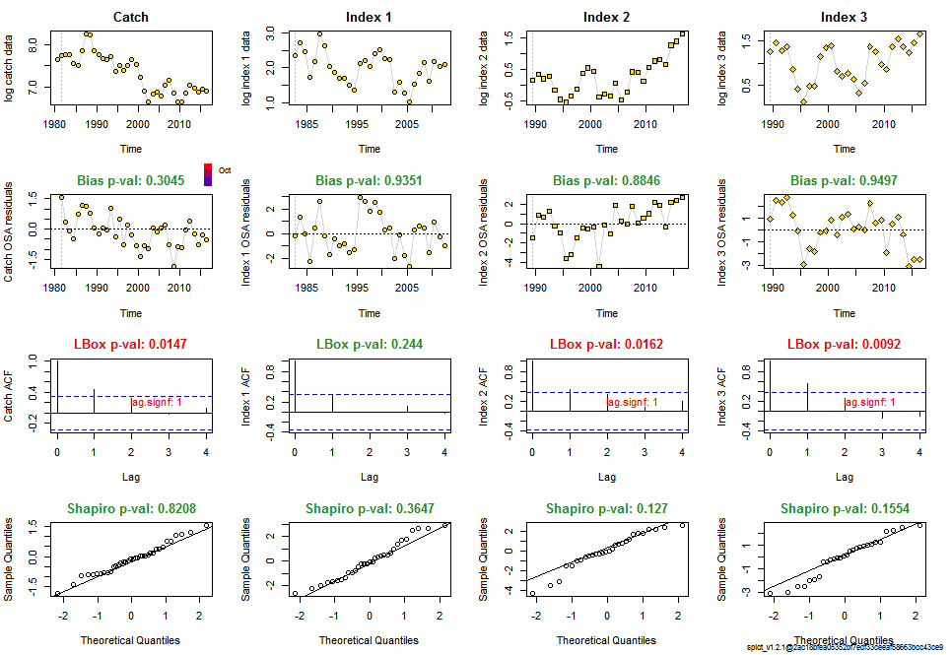

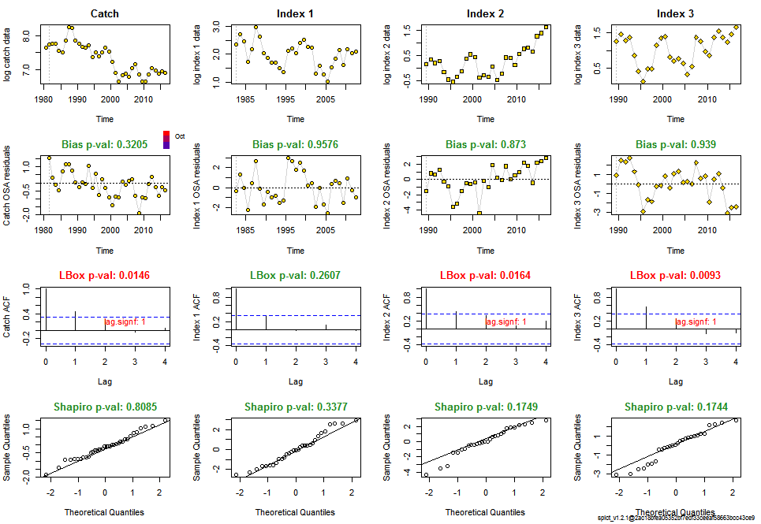

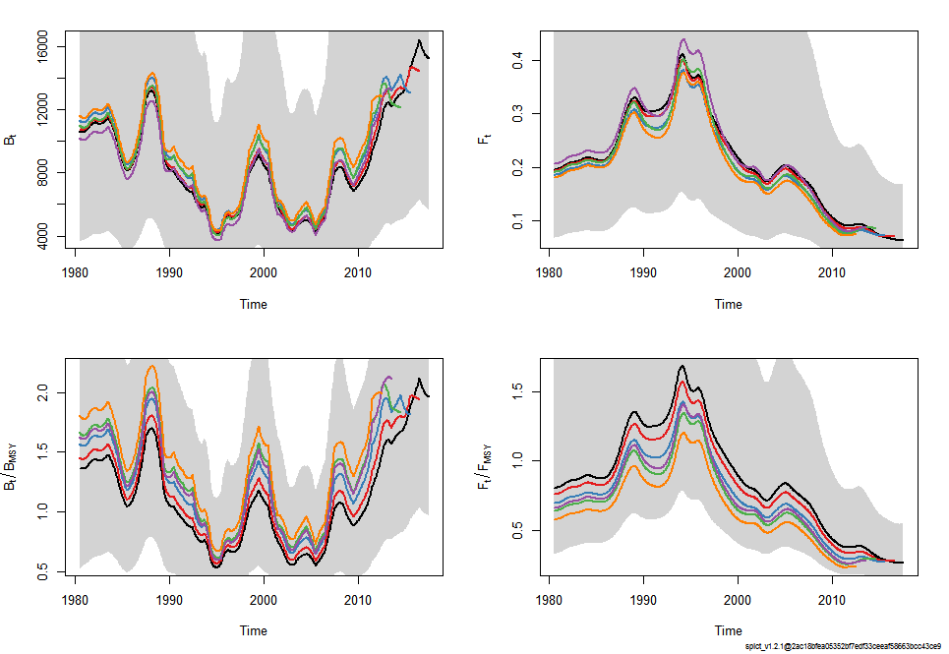

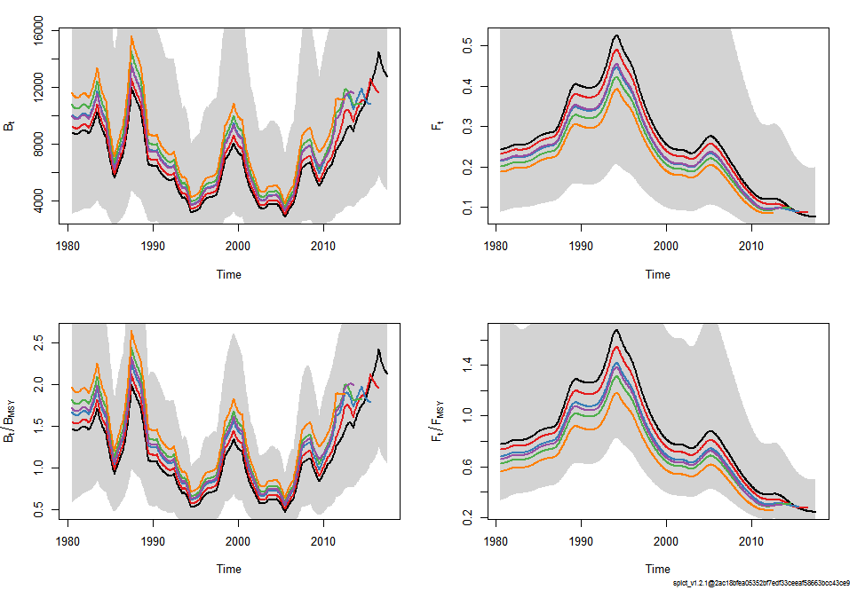

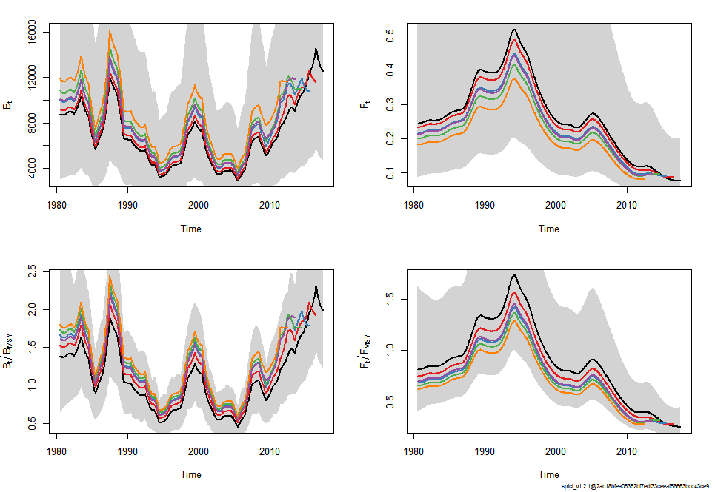

[1] "Convergence: 0 MSG: relative convergence (4)"

[2] "Objective function at optimum: 33.0054275"

[3] "Euler time step (years): 1/16 or 0.0625"

[4] "Nobs C: 37, Nobs I1: 31, Nobs I2: 28, Nobs I3: 28"

[5] ""

[6] "Residual diagnostics (p-values)"

[7] " shapiro bias acf LBox shapiro bias acf LBox "

[8] " C 0.7964 0.4425 0.1342 0.3287 - - - - "

[9] " I1 0.2282 0.8723 0.0174 0.0890 - - * . "

[10] " I2 0.9580 0.6197 0.0184 0.0397 - - * * "

[11] " I3 0.5416 0.6169 0.0133 0.0307 - - * * "

[12] ""

[13] "Priors"

[14] " logn ~ dnorm[log(2), 2^2]"

[15] " logalpha ~ dnorm[log(1), 2^2]"

[16] " logbeta ~ dnorm[log(1), 2^2]"

[17] ""

[18] "Model parameter estimates w 95% CI "

[19] " estimate cilow ciupp log.est "

[20] " alpha1 1.434218e+00 0.9229070 2.228807e+00 0.3606199 "

[21] " alpha2 1.159846e+00 0.6922013 1.943425e+00 0.1482868 "

[22] " alpha3 1.094407e+00 0.6472023 1.850623e+00 0.0902131 "

[23] " beta 1.413639e-01 0.0233813 8.546875e-01 -1.9564181 "

[24] " r 3.701894e-01 0.0288107 4.756570e+00 -0.9937406 "

[25] " rc 4.984816e-01 0.2144635 1.158630e+00 -0.6961886 "

[26] " rold 7.628556e-01 0.0049739 1.169997e+02 -0.2706866 "

[27] " m 2.055839e+03 1367.4663233 3.090735e+03 7.6284396 "

[28] " K 1.863851e+04 5455.6634291 6.367586e+04 9.8329852 "

[29] " q1 9.983000e-04 0.0003865 2.578200e-03 -6.9094590 "

[30] " q2 1.768000e-04 0.0000684 4.568000e-04 -8.6404828 "

[31] " q3 3.803000e-04 0.0001473 9.821000e-04 -7.8745130 "

[32] " n 1.485268e+00 0.1336051 1.651151e+01 0.3955952 "

[33] " sdb 2.184630e-01 0.1587367 3.006621e-01 -1.5211384 "

[34] " sdf 1.529440e-01 0.1049178 2.229540e-01 -1.8776838 "

[35] " sdi1 3.133237e-01 0.2320627 4.230396e-01 -1.1605185 "

[36] " sdi2 2.533834e-01 0.1709836 3.754929e-01 -1.3728516 "

[37] " sdi3 2.390876e-01 0.1642025 3.481242e-01 -1.4309253 "

[38] " sdc 2.162070e-02 0.0036892 1.267078e-01 -3.8341019 "

[39] " "

[40] "Deterministic reference points (Drp)"

[41] " estimate cilow ciupp log.est "

[42] " Bmsyd 8248.4070505 3135.6545457 2.169761e+04 9.017775 "

[43] " Fmsyd 0.2492408 0.1072318 5.793151e-01 -1.389336 "

[44] " MSYd 2055.8394873 1367.4663233 3.090735e+03 7.628440 "

[45] "Stochastic reference points (Srp)"

[46] " estimate cilow ciupp log.est rel.diff.Drp "

[47] " Bmsys 7766.1682414 3038.3347196 1.985080e+04 8.957532 -0.06209482 "

[48] " Fmsys 0.2435681 0.1016636 5.835464e-01 -1.412359 -0.02328995 "

[49] " MSYs 1888.8556394 1374.8907022 2.594952e+03 7.543726 -0.08840477 "

[50] ""

[51] "States w 95% CI (inp$msytype: s)"

[52] " estimate cilow ciupp log.est "

[53] " B_2016.50 1.645024e+04 6355.2890188 4.258034e+04 9.7080953 "

[54] " F_2016.50 6.548060e-02 0.0252171 1.700322e-01 -2.7260007 "

[55] " B_2016.50/Bmsy 2.118193e+00 1.0433480 4.300329e+00 0.7505631 "

[56] " F_2016.50/Fmsy 2.688391e-01 0.1301010 5.555260e-01 -1.3136422 "

[57] ""

[58] "Predictions w 95% CI (inp$msytype: s)"

[59] " prediction cilow ciupp log.est "

[60] " B_2017.50 1.524875e+04 5680.8231207 4.093144e+04 9.6322525 "

[61] " F_2017.50 6.382420e-02 0.0240076 1.696765e-01 -2.7516223 "

[62] " B_2017.50/Bmsy 1.963484e+00 0.9678208 3.983453e+00 0.6747204 "

[63] " F_2017.50/Fmsy 2.620385e-01 0.1240519 5.535117e-01 -1.3392638 "

[64] " Catch_2017.50 9.662766e+02 649.6201307 1.437287e+03 6.8734501 "

[65] " E(B_inf) 1.383856e+04 NA NA 9.5352145 "

[1] "Convergence: 0 MSG: relative convergence (4)"

[2] "Objective function at optimum: 70.2513443"

[3] "Euler time step (years): 1/16 or 0.0625"

[4] "Nobs C: 37, Nobs I1: 31, Nobs I2: 28, Nobs I3: 28"

[5] ""

[6] "Residual diagnostics (p-values)"

[7] " shapiro bias acf LBox shapiro bias acf LBox "

[8] " C 0.8208 0.3045 0.0062 0.0147 - - ** * "

[9] " I1 0.3647 0.9351 0.0517 0.2440 - - . - "

[10] " I2 0.1270 0.8846 0.0181 0.0162 - - * * "

[11] " I3 0.1554 0.9497 0.0029 0.0092 - - ** ** "

[12] ""

[13] "Priors"

[14] " logn ~ dnorm[log(2), 2^2]"

[15] " logalpha ~ dnorm[log(1), 2^2]"

[16] " logbeta ~ dnorm[log(1), 2^2]"

[17] ""

[18] "Fixed parameters"

[19] " fixed.value "

[20] " sdc 0.10 "

[21] " sdi 0.15 "

[22] ""

[23] "Model parameter estimates w 95% CI "

[24] " estimate cilow ciupp log.est "

[25] " beta 6.085629e-01 0.4164714 8.892540e-01 -0.4966550 "

[26] " r 4.492040e-01 0.0477647 4.224544e+00 -0.8002781 "

[27] " rc 6.421626e-01 0.2908193 1.417969e+00 -0.4429137 "

[28] " rold 1.125726e+00 0.0053420 2.372235e+02 0.1184279 "

[29] " m 2.075938e+03 1394.6308149 3.090078e+03 7.6381683 "

[30] " K 1.499866e+04 4902.4522158 4.588719e+04 9.6157161 "

[31] " q1 1.267900e-03 0.0005090 3.158400e-03 -6.6704022 "

[32] " q2 2.255000e-04 0.0000904 5.626000e-04 -8.3972577 "

[33] " q3 4.850000e-04 0.0001944 1.210200e-03 -7.6312879 "

[34] " n 1.399035e+00 0.1700799 1.150811e+01 0.3357827 "

[35] " sdb 2.686618e-01 0.2015253 3.581642e-01 -1.3143021 "

[36] " sdf 1.643215e-01 0.1124538 2.401125e-01 -1.8059301 "

[37] " "

[38] "Deterministic reference points (Drp)"

[39] " estimate cilow ciupp log.est "

[40] " Bmsyd 6465.4585390 2562.3512314 1.631398e+04 8.774229 "

[41] " Fmsyd 0.3210813 0.1454096 7.089847e-01 -1.136061 "

[42] " MSYd 2075.9379129 1394.6308149 3.090078e+03 7.638168 "

[43] "Stochastic reference points (Srp)"

[44] " estimate cilow ciupp log.est rel.diff.Drp "

[45] " Bmsys 5999.5777618 2457.3526236 1.464785e+04 8.699444 -0.07765226 "

[46] " Fmsys 0.3141442 0.1378593 7.158497e-01 -1.157903 -0.02208257 "

[47] " MSYs 1881.5004349 1386.9836363 2.552333e+03 7.539825 -0.10334171 "

[48] ""

[49] "States w 95% CI (inp$msytype: s)"

[50] " estimate cilow ciupp log.est "

[51] " B_2016.50 1.451930e+04 5776.6763514 3.649334e+04 9.583234 "

[52] " F_2016.50 7.801300e-02 0.0304804 1.996702e-01 -2.550880 "

[53] " B_2016.50/Bmsy 2.420054e+00 1.2503472 4.684029e+00 0.883790 "

[54] " F_2016.50/Fmsy 2.483349e-01 0.1227927 5.022304e-01 -1.392977 "

[55] ""

[56] "Predictions w 95% CI (inp$msytype: s)"

[57] " prediction cilow ciupp log.est "

[58] " B_2017.50 1.276680e+04 4725.380377 3.449273e+04 9.4546036 "

[59] " F_2017.50 7.599380e-02 0.028806 2.004808e-01 -2.5771034 "

[60] " B_2017.50/Bmsy 2.127950e+00 1.055429 4.290362e+00 0.7551592 "

[61] " F_2017.50/Fmsy 2.419074e-01 0.115692 5.058188e-01 -1.4192001 "

[62] " Catch_2017.50 9.534497e+02 577.654106 1.573721e+03 6.8600867 "

[63] " E(B_inf) 1.099121e+04 NA NA 9.3048507 "

[1] "Convergence: 0 MSG: relative convergence (4)"

[2] "Objective function at optimum: 70.3212418"

[3] "Euler time step (years): 1/16 or 0.0625"

[4] "Nobs C: 37, Nobs I1: 31, Nobs I2: 28, Nobs I3: 28"

[5] ""

[6] "Residual diagnostics (p-values)"

[7] " shapiro bias acf LBox shapiro bias acf LBox "

[8] " C 0.8085 0.3205 0.0055 0.0146 - - ** * "

[9] " I1 0.3377 0.9576 0.0568 0.2607 - - . - "

[10] " I2 0.1749 0.8730 0.0182 0.0164 - - * * "

[11] " I3 0.1744 0.9390 0.0029 0.0093 - - ** ** "

[12] ""

[13] "Priors"

[14] " logn ~ dnorm[log(2), 2^2]"

[15] " logalpha ~ dnorm[log(1), 2^2]"

[16] " logbeta ~ dnorm[log(1), 2^2]"

[17] ""

[18] "Fixed parameters"

[19] " fixed.value "

[20] " n 2.00 "

[21] " sdc 0.10 "

[22] " sdi 0.15 "

[23] ""

[24] "Model parameter estimates w 95% CI "

[25] " estimate cilow ciupp log.est "

[26] " beta 6.119885e-01 0.4192234 8.933897e-01 -0.4910419 "

[27] " r 6.343565e-01 0.2961862 1.358633e+00 -0.4551442 "

[28] " rc 6.343565e-01 0.2961862 1.358633e+00 -0.4551442 "

[29] " rold 6.343565e-01 0.2961862 1.358633e+00 -0.4551442 "

[30] " m 2.183675e+03 1592.5646712 2.994186e+03 7.6887644 "

[31] " K 1.376938e+04 5835.5229208 3.248997e+04 9.5302029 "

[32] " q1 1.252800e-03 0.0004991 3.144900e-03 -6.6823731 "

[33] " q2 2.229000e-04 0.0000887 5.601000e-04 -8.4089953 "

[34] " q3 4.794000e-04 0.0001908 1.204700e-03 -7.6430255 "

[35] " sdb 2.682200e-01 0.2015028 3.570271e-01 -1.3159477 "

[36] " sdf 1.634018e-01 0.1119332 2.385363e-01 -1.8115432 "

[37] " "

[38] "Deterministic reference points (Drp)"

[39] " estimate cilow ciupp log.est "

[40] " Bmsyd 6884.6922627 2917.7614604 1.624498e+04 8.837056 "

[41] " Fmsyd 0.3171783 0.1480931 6.793163e-01 -1.148291 "

[42] " MSYd 2183.6746679 1592.5646712 2.994186e+03 7.688764 "

[43] "Stochastic reference points (Srp)"

[44] " estimate cilow ciupp log.est rel.diff.Drp "

[45] " Bmsys 6333.2662450 2736.6778697 1.465655e+04 8.753571 -0.08706819 "

[46] " Fmsys 0.2998317 0.1353664 6.641162e-01 -1.204534 -0.05785430 "

[47] " MSYs 1889.3485702 1386.0020179 2.575493e+03 7.543987 -0.15578179 "

[48] ""

[49] "States w 95% CI (inp$msytype: s)"

[50] " estimate cilow ciupp log.est "

[51] " B_2016.50 1.459331e+04 5756.8030854 3.699358e+04 9.5883186 "

[52] " F_2016.50 7.804630e-02 0.0302511 2.013555e-01 -2.5504526 "

[53] " B_2016.50/Bmsy 2.304232e+00 1.4561676 3.646203e+00 0.8347472 "

[54] " F_2016.50/Fmsy 2.603005e-01 0.1535807 4.411776e-01 -1.3459186 "

[55] ""

[56] "Predictions w 95% CI (inp$msytype: s)"

[57] " prediction cilow ciupp log.est "

[58] " B_2017.50 1.257741e+04 4673.8229984 3.384620e+04 9.439657 "

[59] " F_2017.50 7.628410e-02 0.0287226 2.026023e-01 -2.573291 "

[60] " B_2017.50/Bmsy 1.985927e+00 1.2296306 3.207392e+00 0.686086 "

[61] " F_2017.50/Fmsy 2.544231e-01 0.1441383 4.490905e-01 -1.368756 "

[62] " Catch_2017.50 9.378434e+02 586.6805172 1.499198e+03 6.843583 "

[63] " E(B_inf) 1.036583e+04 NA NA 9.246270 "

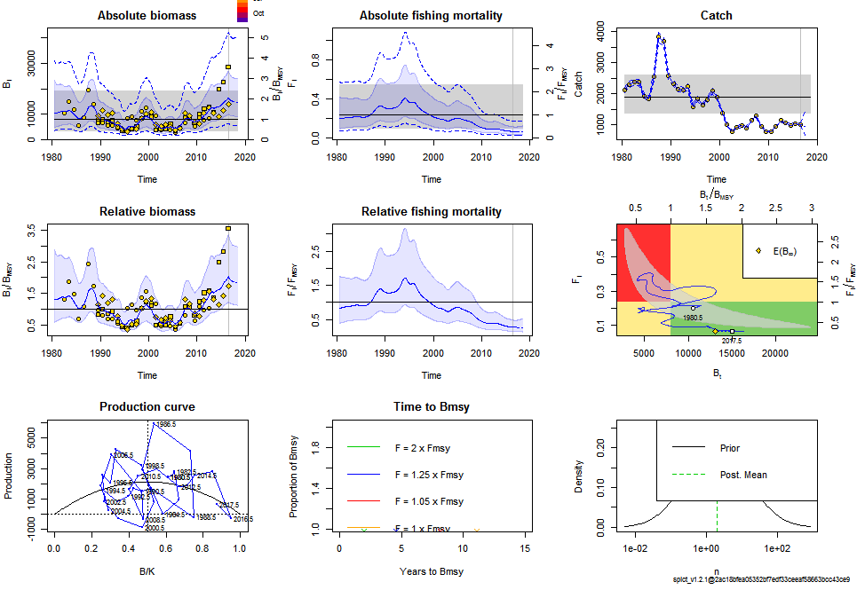

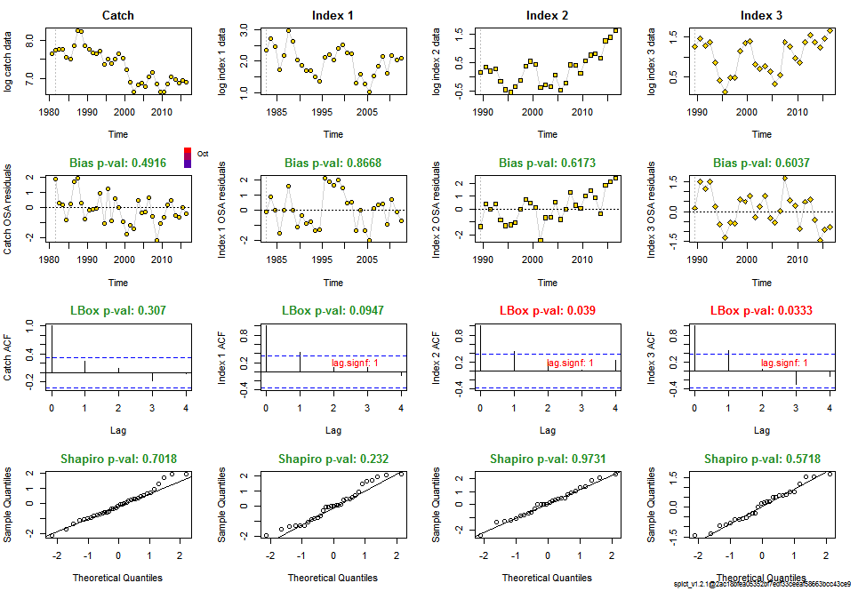

[1] "Convergence: 0 MSG: relative convergence (4)"

[2] "Objective function at optimum: 33.0394945"

[3] "Euler time step (years): 1/16 or 0.0625"

[4] "Nobs C: 37, Nobs I1: 31, Nobs I2: 28, Nobs I3: 28"

[5] ""

[6] "Residual diagnostics (p-values)"

[7] " shapiro bias acf LBox shapiro bias acf LBox "

[8] " C 0.7018 0.4916 0.1291 0.3070 - - - - "

[9] " I1 0.2320 0.8668 0.0184 0.0947 - - * . "

[10] " I2 0.9731 0.6173 0.0184 0.0390 - - * * "

[11] " I3 0.5718 0.6037 0.0142 0.0333 - - * * "

[12] ""

[13] "Priors"

[14] " logn ~ dnorm[log(2), 2^2]"

[15] " logalpha ~ dnorm[log(1), 2^2]"

[16] " logbeta ~ dnorm[log(1), 2^2]"

[17] ""

[18] "Fixed parameters"

[19] " fixed.value "

[20] " n 2 "

[21] ""

[22] "Model parameter estimates w 95% CI "

[23] " estimate cilow ciupp log.est "

[24] " alpha1 1.433838e+00 0.9230506 2.227278e+00 0.3603545 "

[25] " alpha2 1.169689e+00 0.7037572 1.944097e+00 0.1567379 "

[26] " alpha3 1.093044e+00 0.6466311 1.847646e+00 0.0889667 "

[27] " beta 1.419067e-01 0.0234410 8.590730e-01 -1.9525853 "

[28] " r 4.964333e-01 0.2216886 1.111677e+00 -0.7003061 "

[29] " rc 4.964333e-01 0.2216886 1.111677e+00 -0.7003061 "

[30] " rold 4.964333e-01 0.2216886 1.111677e+00 -0.7003061 "

[31] " m 2.130578e+03 1541.9229100 2.943962e+03 7.6641485 "

[32] " K 1.716708e+04 7032.6212229 4.190595e+04 9.7507489 "

[33] " q1 9.930000e-04 0.0003825 2.577900e-03 -6.9148088 "

[34] " q2 1.760000e-04 0.0000678 4.567000e-04 -8.6449466 "

[35] " q3 3.786000e-04 0.0001460 9.819000e-04 -7.8789768 "

[36] " sdb 2.181234e-01 0.1586220 2.999447e-01 -1.5226941 "

[37] " sdf 1.523356e-01 0.1046241 2.218050e-01 -1.8816690 "

[38] " sdi1 3.127536e-01 0.2317206 4.221239e-01 -1.1623396 "

[39] " sdi2 2.551366e-01 0.1736210 3.749239e-01 -1.3659563 "

[40] " sdi3 2.384186e-01 0.1639869 3.466339e-01 -1.4337275 "

[41] " sdc 2.161750e-02 0.0036843 1.268397e-01 -3.8342543 "

[42] " "

[43] "Deterministic reference points (Drp)"

[44] " estimate cilow ciupp log.est "

[45] " Bmsyd 8583.5404397 3516.3106114 2.095297e+04 9.057602 "

[46] " Fmsyd 0.2482167 0.1108443 5.558384e-01 -1.393453 "

[47] " MSYd 2130.5778307 1541.9229100 2.943962e+03 7.664148 "

[48] "Stochastic reference points (Srp)"

[49] " estimate cilow ciupp log.est rel.diff.Drp "

[50] " Bmsys 8047.398927 3362.856162 1.925763e+04 8.993104 -0.06662296 "

[51] " Fmsys 0.236561 0.102698 5.449096e-01 -1.441549 -0.04927131 "

[52] " MSYs 1897.451799 1378.430203 2.611901e+03 7.548267 -0.12286269 "

[53] ""

[54] "States w 95% CI (inp$msytype: s)"

[55] " estimate cilow ciupp log.est "

[56] " B_2016.50 1.634228e+04 6311.4574427 4.231514e+04 9.7015111 "

[57] " F_2016.50 6.604870e-02 0.0254654 1.713078e-01 -2.7173632 "

[58] " B_2016.50/Bmsy 2.030753e+00 1.2287687 3.356172e+00 0.7084069 "

[59] " F_2016.50/Fmsy 2.792036e-01 0.1607968 4.848023e-01 -1.2758141 "

[60] ""

[61] "Predictions w 95% CI (inp$msytype: s)"

[62] " prediction cilow ciupp log.est "

[63] " B_2017.50 1.501989e+04 5646.2460582 3.995522e+04 9.6171303 "

[64] " F_2017.50 6.454610e-02 0.0243642 1.709971e-01 -2.7403753 "

[65] " B_2017.50/Bmsy 1.866427e+00 1.1532734 3.020577e+00 0.6240261 "

[66] " F_2017.50/Fmsy 2.728519e-01 0.1532719 4.857259e-01 -1.2988262 "

[67] " Catch_2017.50 9.590054e+02 654.8407203 1.404451e+03 6.8658967 "

[68] " E(B_inf) 1.309869e+04 NA NA 9.4802678 "

